No exceptions! You must show all work and/or explain your answers to receive full credit.
( 10 points)
Please Note : It is recommended that you print and write out your answers. Scan/take a photo and upload to the drop-box in Unit 7, Lesson 6 Slide 3. (You may use extra paper as needed – make sure it is uploaded as well.)

L Lesson 5-1. Find the value of x.
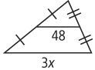

Lesson 5-2.

- Find an equation in slope-intercept form for the perpendicular bisector of the segment with endpoints H(–3, 2) and K(7, –5).

Lesson 5-3. Find the center of the circle that you can circumscribe about ΔABC.
3. A(2, 8)
B(0, 8)
C(2, 2)

Lesson 5-4.
4. Tell which line contains each point for ∆ABC.
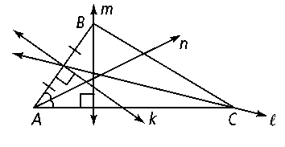
a. the circumcenter ____________
b. the orthocenter ____________
c. the centroid ____________
d. the incenter ____________

Lesson 5-5. Write the first step of an indirect proof.

5. Points J, K, and L are collinear.

Lesson 5-6. Can a triangle have sides with the given lengths? Explain.
6. 8 ft, 9 ft, 18 ft

Lesson 5-7. Find the range of possible values for the variable.

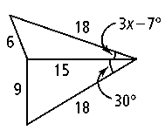
7.

